Hakstock E-commerce Website

Software Requirements Specification

Version 1.0

February 16, 2016

Abdulhakeem Usman
Lead Software Engineer

Prepared for
COMP 295—Systems Development
Instructor: DJ Moffatt.

Revision History

Date | Description | Author | Comments
02/16/16 | Version 1.0 | Abdulhakeem Usman | Revision 1

Document Approval

The following Software Requirements Specification has been accepted and approved by the following:
Signature | Printed Name | Title | Date
 | Abdulhakeem Usman | Lead Software Eng. | 16-Feb-2016

Table of Contents

Revision History ii
Document Approval ii
1. Introduction 1
1.1 Purpose 1
1.2 Scope 1
1.3 Definitions, Acronyms, and Abbreviations 1
1.4 References 2
1.5 Overview 2
2. General Description 2
2.1 Product Perspective 3
2.2 Product Functions 3
2.3 User Characteristics 3
2.4 General Constraints 3
2.5 Assumptions and Dependencies 3
3. Specific Requirements 4
3.1 External Interface Requirements 4
3.1.1 User Interfaces 4
3.1.2 Hardware Interfaces 4
3.1.3 Software Interfaces 4
3.1.4 Communications Interfaces 4
3.2 Functional Requirements 4
3.2.1 Login Requirement 4
3.2.2 Register Requirement 5
3.2.3 Shopping Cart Requirement 5
3.2.4 Search Item Requirement 5
3.2.5 Admin Requirement 6
3.2.7 Account Status Requirement 6
3.3 Non-Functional Requirements 7
3.3.1 Performance 7
3.3.2 Reliability 7
3.3.3 Availability 7
3.3.4 Security 7
3.3.5 Maintainability 7
3.3.6 Portability 7
3.4 Inverse Requirements 7
3.5 Design Constraints 8
3.6 Logical Database Requirements 8
3.7 Other Requirements 8
4. Analysis Models 8
4.1 Use Cases 9
4.1.1 Login Use Case 11
4.1.2 Browse/Search Item Use Case 11
4.1.3 Checkout/Pay Use Case 12
4.1.4 View Account Use Case 12
4.1.5 Edit Account Info Use Case 12
4.1.6 Cancel Account Use Case 12
4.1.7 Register Use Case 13
4.1.8 Manage Database Use Case 13
4.2 Data Flow Diagrams (DFD) 15
4.2.1 Context Data Flow 15
4.2.2 Level 1 User Data Flow 15
4.2.3 Level 1 Admin Data Flow 16
5. Change Management Process 16

1. Introduction
The Software Requirements Specification is designed to provide a clear and descriptive statement of requirements that can be used as a reference in further development of the software. This document is broken into a number of sections that separate the software requirements into easily referenced parts.

This Software Requirements Specification aims to describe the functionality, external interfaces, attributes and design constraints of the Hakstock E-commerce website. Throughout the description of the software system, the language and terminology used may be a bit ambiguous throughout the document.

1.1 Purpose
The purpose of this document is to provide a comprehensive description of the functionalities and specifications of the Hakstock e-commerce website. The intended audience of this document are the Hakstock customers as well as the entire spring 2016 COMP 295 Systems Development class.

1.2 Scope
Hakstock is an e-commerce website designed for customers interested in purchasing goods of notable electronic items, and self-produced graphic clothing for a cheaper, suitable sale price. The website will use the combination of Amazon and e-Bay e-commerce models. The e-commerce website will allow any user to create an account to become a customer. The customer being a member will have access to certain discount deals. The website will allow customers to search, filter, select, and add goods to a shopping cart. Customers will be provided with a sufficient idea of what they will be purchasing based on the product description and also reviews from other customers. The website will also allow an individual with an admin account to manage the inventory with full create, retrieve, update and delete (CRUD) functionality with regards to the products stored in the database. Users will be able to receive confirmation email and shipping details after placing an order with us.

The website will have a few constraints. The website will only be in English language and customers may not be able to processing payments via credit cards with our initial method of payment being PayPal. The website will only function if the user is connected to the Internet. The website will be developed with PHP; hence the user must have Apache installed for the website to function well.
.

1.3 Definitions, Acronyms, and Abbreviations
Admin | A user with privileges allowing them to control the activity of other users.
Apache | A free open-source licensed web server available for different operating systems.
E-commerce | Trading of goods and services over an electronic network, usually the Internet.
Checkout | Point at which goods and services bought online are paid for.
CRUD | Create, Retrieve, Update, Delete
Customer | A person or organization that buys goods or services from a store or business
DFD | Data Flow Diagram
Goods | Merchandise or products.
GUI | Graphical User Interface.
IEEE | Institute of Electrical and Electronics Engineers.
Inventory | A complete list of items and goods in stock.
Item | A particular product.
PHP | A server-side scripting language designed for web development.
Shopping Cart | Component that allows customers to gather a list of items they wish to purchase.
SRS | Software Requirements Specification
User | Person who uses or operates something, especially a computer or other machine.
.

References
- Hakstock E-commerce Website Project Scope
- IEEE Guide to Software Requirements Specification (ANSI/IEEE Std. 830-1984)

1.5 Overview
The SRS document is divided into five different sections. The first section of the document contains the purpose, scope and overview of the document as well as some common definitions, acronyms and abbreviations that will be used in the document. The second section details the general description of the software and is divided into five subsections: product perspective, product functions, user characteristics, general constraints, and assumptions. The third section encompasses of all the specific requirements of the software which include the interface requirements, functional, non-functional and supplementary requirements. The fourth section lists all the analysis models to be used in the development of the project. This would also include the DFD. The last section is the Change Management Process which describes the process that would be used to upgrade the SRS should any change in specific documents arise.

2. General Description
The Hakstock e-commerce application enables customers to browse through the website in search of their preferred items, and also enables a system admin to approve and reject requests for new shops and maintain lists of shop categories. The online shopping system will use the internet as the sole method for selling goods to its consumers.

This section of the SRS document details the product perspective from the different stakeholders. It also provides the detail product functions of the website with the user characteristics, general constraints, assumptions and dependencies.

2.1 Product Perspective
Hakstock is an e-commerce website that would provide products at the cheaper rate than other e-commerce systems. The website would be available to anyone with access to a suitable Internet connection.

2.2 Product Functions
Hakstock will perform a number of functions as listed below:
• Maintain records for many customers.
• A customer can be either a member or non-member.
• A customer has a username, password, email address and postal address.
• Anyone may sign up for a customer account.
• Allow any customer to become a member.
• Each product will have its own description on its functions and other important details.
• Allow customers and managers to log in and out of the system.
• Provide a shopping cart to add goods into.
• A Checkout system which may allow customers to sign up for an account.
• Member customers may enter a promotion code.
• Log/record each transaction completed.
• Allow admin to update product details such as price, description, images, etc.
• Allow admin to view transaction logs and email customers valuable information about product they ordered.

2.3 User Characteristics
The users of this website include the public and an admin. The users are required to have basic knowledge and experience using a web browser. However, the GUI should provide enough guidance to an average user. System admins should have knowledge of the specifics of hardware, operating system and software environment of the host system. This includes but is not limited to the knowledge of web server and database administration. Preferably the administrator will have basic knowledge of SQL.

2.4 General Constraints
- The developed system should run under any platform that contains a web browser which supports PHP, JavaScript and AJAX.
- The website will be developed with PHP; hence the user must have Apache installed for the website to function well.
- Connection to the Internet will be mandatory for the development of this website.

2.5 Assumptions and Dependencies
Assumptions:
- The website will only be in English language and user input will be in a single language only.
- The website might only function if the user is connected to the Internet.
Dependencies:
- Implementation of additional features and upgrades is entirely dependent upon the time spent designing and implementing the main features and requirements.

3. Specific Requirements
The website requirements are as follows:

3.1 External Interface Requirements

3.1.1 User Interfaces
- The website will run on any modern browser; Internet Explorer, Firefox, Google Chrome, and Safari for Windows. Website will be developed on a screen resolution of 1024 x 768.

3.1.2 Hardware Interfaces
- Since the website must run over the Internet, all hardware components (PC) require connection to the Internet.

3.1.3 Software Interfaces
- Use and knowledge of Apache Web server and MySQL DBMS is required.

3.1.4 Communications Interfaces
- The e-commerce website will use HTTP protocol for communication.

3.2 Functional Requirements

3.2.1 Login Requirement
3.2.1.1 Introduction
The login function grants users access to specific functions of the Hakstock website.
3.2.1.2 Inputs
Username or email, password.

3.2.1.3 Processing
The login function takes in a username and a password. It runs a check against the database to verify this information. If the check is successful then it will grant the user access for the session.

3.2.1.4 Outputs
User key/access. .

3.2.1.5 Error Handling
The application will not allow users to login unless they are registered members. If the user is a registered member and has forgotten his password, then an error message appears and gives the user a link to where they can change their password.

3.2.2 Register Requirement
3.2.2.1 Introduction
This function allows a user to enter in their information and creates a user account for that individual.

3.2.2.2 Inputs
User information

3.2.2.3 Processing
The user enters in their name, email address, and preferred password and the website creates an account for the user.

3.2.2.4 Outputs
E-mail confirmation, new user record.

3.2.2.5 Error Handling
A user cannot register twice with the same email address and also if his email address matches a registered customer’s own.

3.2.3 Shopping Cart Requirement
3.2.3.1 Introduction
The shopping cart function allows a registered user to purchase items from Hakstock and provides them with information about their order.

3.2.3.2 Inputs
User access.
Item.
Item Quantity, Size/Color Selected.

3.2.3.3 Processing
The shopping cart takes the user’s info and the items that the user wants to purchase and creates a transaction record.

3.2.3.4 Outputs
Transaction Record

3.2.3.5 Error Handling
If the user enters a non-positive or non-integer quantity, the system displays an error message.

3.2.4 Search Item Requirement
3.2.4.1 Introduction
This function allows the user to search for items using keywords.

3.2.4.2 Inputs
String typed in the search box.

3.2.4.3 Processing
The application takes search parameters from the user, and parses them. It then searches the index for the item that match the search strings and displays it to the user.

3.2.4.4 Outputs
Items

3.2.4.5 Error Handling
If the search returns no results, then the system displays the message “No matches found”

3.2.5 Admin Requirement
3.2.5.1 Introduction
This function allows individuals with admin privileges to access the back-end and maintain the system.

3.2.5.2 Inputs
Username, password

3.2.5.3 Processing
This function provides an administrator with an interface to manage and maintain the system. The admin has access to all the information stored in the database and has the ability to change, or update users, items and properties of these entities.

3.2.5.4 Outputs
Modifications to database.

3.2.5.5 Error Handling
If the user fails to enter any of the mandatory user inputs, then the system displays an appropriate error message to the user.

3.2.7 Account Status Requirement
3.2.2.1 Introduction
This function allows a user to view activity on their account and modify his/her membership information.

3.2.2.2 Inputs
User access.

3.2.2.3 Processing
The system identifies the user and with that the user can fetch account information. The user can view their transaction records and also modify their membership information.

3.2.2.4 Outputs
User record.

3.2.2.5 Error Handling
If the user clicks “My Account” without being logged in, the system proceeds to the page asking them to login or buy a product to register.

3.3 Non-Functional Requirements

3.3.1 Performance
- Performance requirement depends on the end user’s internet connection.

3.3.2 Reliability
- The system provides storage of all databases on redundant computers with automatic switchover.
- The reliability of the overall program depends on the reliability of the separate components. The main pillar of reliability of the system is the backup of the database which is continuously maintained and updated to reflect the most recent changes. Thus the overall stability of the system depends on the stability of container and its underlying operating system

3.3.3 Availability
- The website shall be available for use at 24 hours a day, 7 days a week.
- In case of a hardware failure or database corruption, a replacement page will be shown and database will be backed up by admin.

3.3.4 Security
- The back-end servers are only accessible to authorized admin personnel.
- The system must automatically log out all customers after a period of inactivity.

3.3.5 Maintainability
- A commercial database is used for maintaining the database and the application server takes care of the site. In case of a failure, a re-initialization of the program will be done. Also the software design is being done with modularity in mind so that maintainability can be done efficiently.

3.3.6 Portability
- The application is written in PHP and little bit of HTML which makes the end-user’s side fully portable and any system using any web browser should be able to use the features of the system, including any hardware platform that is available or will be available in the future.
- An end-user can use this system on any OS; whether Windows or Linux.
- The system shall run on PC, Laptops, and maybe mobile phones.

3.4 Inverse Requirements
None.

3.5 Design Constraints
- The system shall be built using a standard web page development tool that conforms to GUI standards.

3.6 Logical Database Requirements
- The system must store all the user account information as well as transaction records in a database. For each user account, the login ID, name, password, age, email address shall be stored in the database. The email address gives the user option to receive any further information about promotions and sales.

3.7 Other Requirements
No additional requirements.

4. Analysis Models
The development of the system will involve the utilization of the Water Fall Model, which follows a linear organization structure. First, the requirements are stated in the software and functional requirement specification document. Then, a system design detailing the data and software architecture of the system is prepared, which is then followed by the implementation stage. The implementation stage would be the core development stage. After development, the system undergoes unit testing and if it does pass the testing phase, then it is ready for deployment. The website would also undergo maintenance once in a while. Maintenance will include CRUD items on the database, upgrading the style of technology utilized and also quarterly testing of the website.

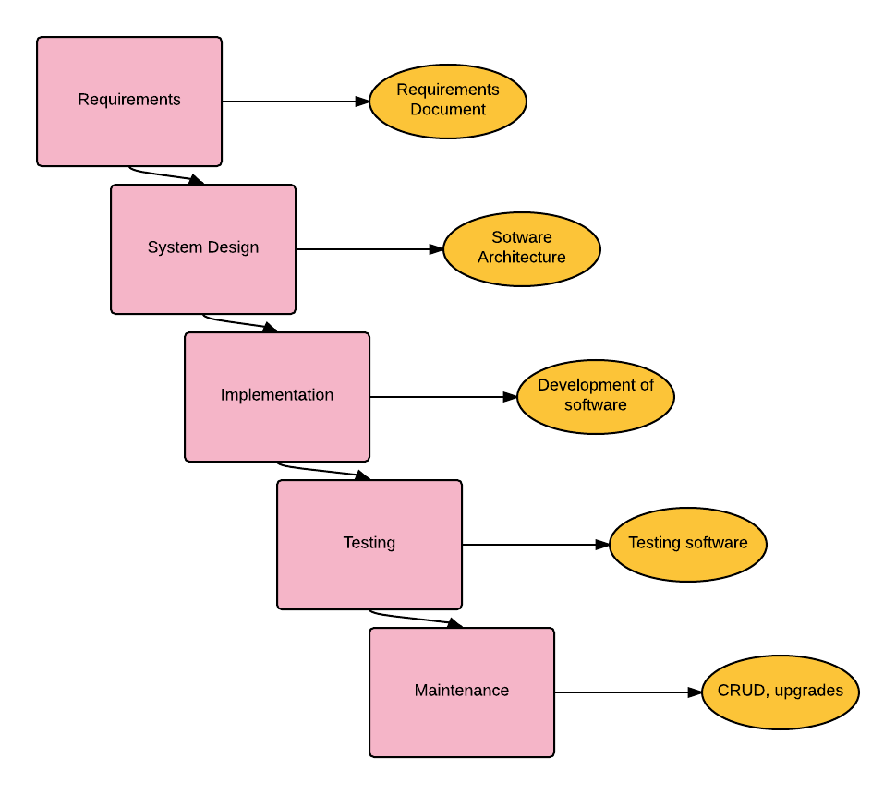

4.1 Use Cases
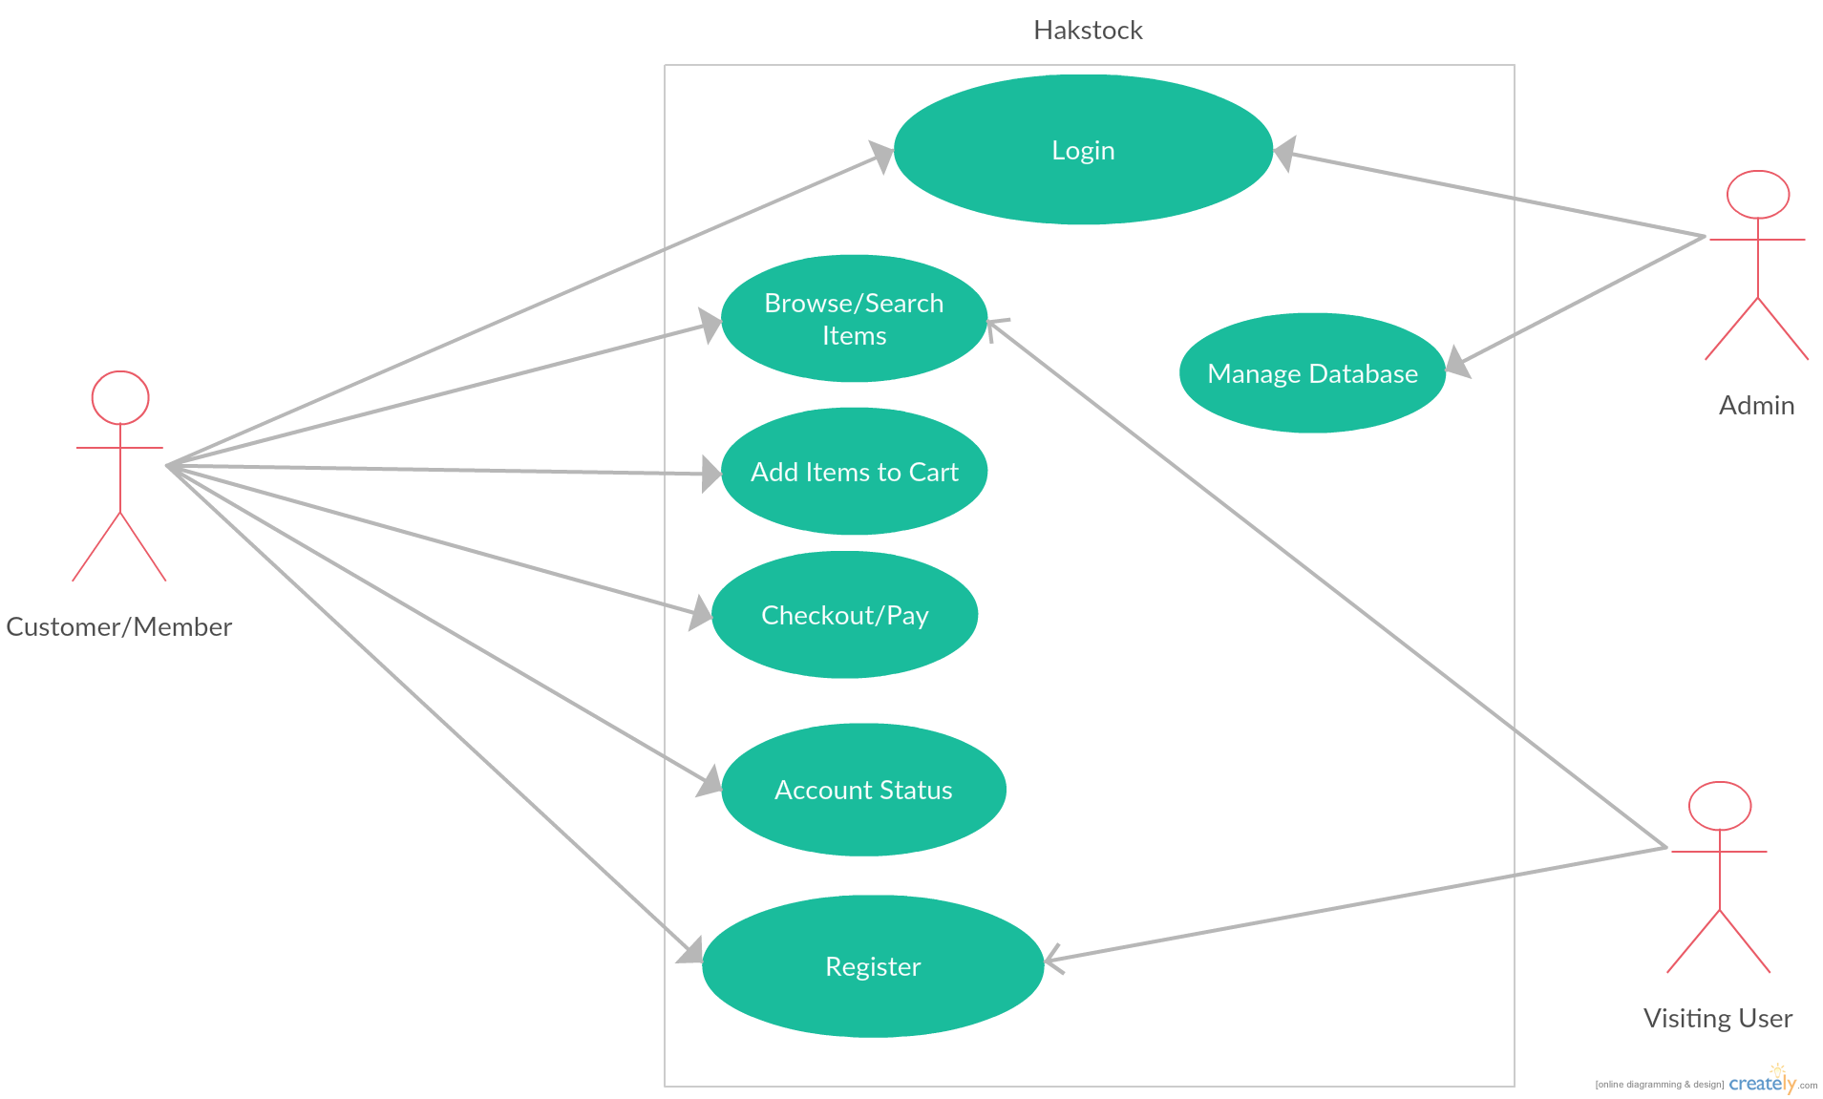

Fig. 1.1 Entire Hakstock System Use Case Diagram

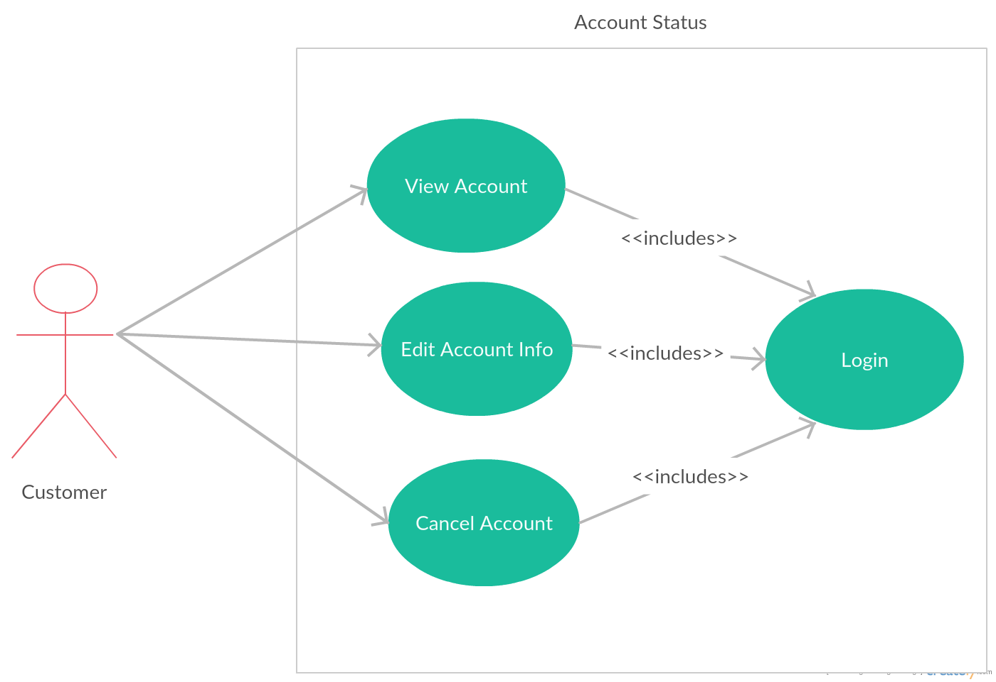

Fig. 1.2 Account Status Use Case Diagram

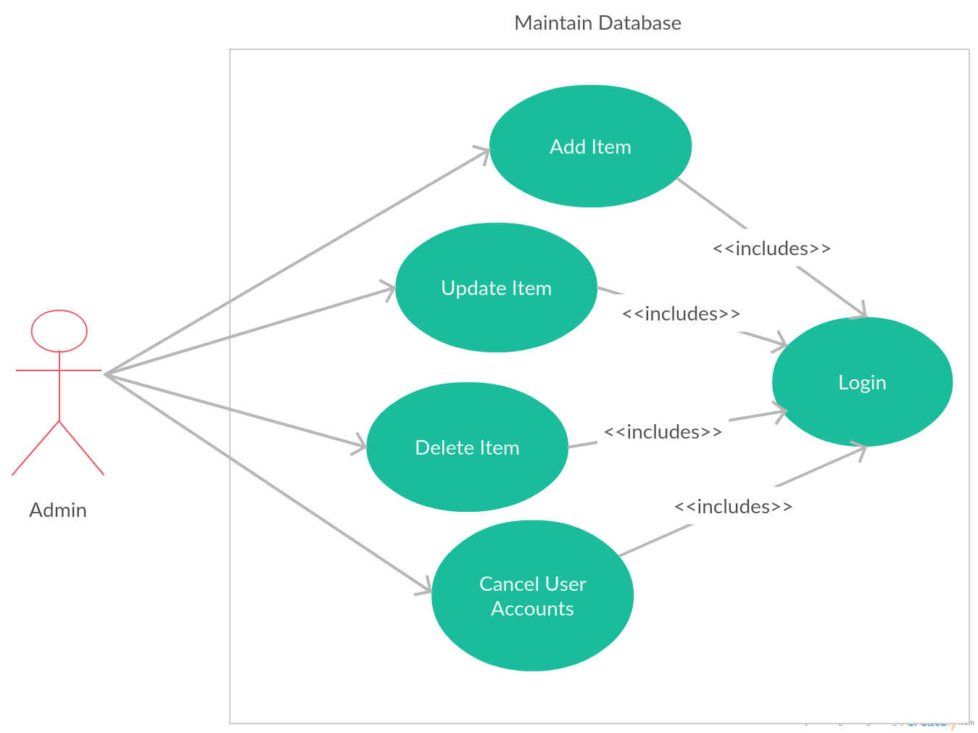

Fig 1.3 Maintain Database Use Case Diagram

4.1.1 Login Use Case
Description: This use case describes how users gain access to the website through the login process.
Actor: User (Customer, Admin).
Scenario for Customer:
- The user browses to the “My Account” page.
- The user enters his/her email and password in the returning user section of the "Sign in" screen.
- The system validates the email and password (successfully) and displays the user's account information page.
Scenario for Admin:
- The user goes to the admin page.
- System prompts the user to enter their email address and password.
- System validates the email and password and displays the admin home page.

4.1.2 Browse/Search Item Use Case
Description: This use case describes how the User can search/browse items on the website.
Actor: User (Customer).
Scenario for Browse:
- The user opens his browser and goes to the “Hakstock” web page.
- The website is launched.
- User scrolls to the menu option on top of the page and he chooses whatever Department option.
Scenario for Search:
- The user opens his browser and goes to the “Hakstock” Web Page.
- The website is launched.
- User enters text in text box next to Search button and clicks on Search button.
- System displays the matching text products.
- User clicks on the desired link. User can navigate back to the earlier pages if wishes.

4.1.3 Checkout/Pay Use Case
Description: This use case describes when the User has successfully added items to his cart and is ready to purchase them.
Actor: User (Customer).
Scenario: Assuming the customer has added his preferred item(s) to the cart.
- System prompts user to select preferred method of payment. If user chooses to pay via PayPal, the system proceeds to ask for the user’s PayPal information. If the user chooses to pay via Credit Card, the system prompts
- After the user has provided the necessary information and has successfully purchased the item, a confirmation message with the user’s transaction number appears on the screen.
- Also, a confirmation e-mail showing necessary details is sent to the user’s email address.

4.1.4 View Account Use Case
Description: This use case describes how the User can check their account information. See Fig 1.2
Actor: User (Customer).
Scenario: Assuming the customer is already logged into the website.
- User clicks the “My Account” link.
- System prompts user to login.
- System displays the Account Information Page when user is logged in.

4.1.5 Edit Account Info Use Case
Description: This use case describes how the User can check their account information. See Fig 1.2
Actor: User (Customer).
Scenario: Assuming the customer is already logged into the website.
- User clicks the “My Account” link.
- System displays the Account Information Page.
- User clicks on the ''Update Account'' link
- User edits his account information and clicks on “Update”.
- System displays the confirmation message “Account Information Changed”.

4.1.7 Register Use Case
Description: This use case describes how a new User can register with e-store
Actor: User
Scenario: The website’s home page is loaded.
- The new user clicks on the “My Account” link.
- The system asks the user if he wishes to login or create a new account assuming the user is not logged in.
- The user clicks on Create a New Account.
- The new user enters the following details in the Account Information Screen.
- First Name
- Last Name
- Street Address
- City
- State of Province
- Country
- Postal Code
- Telephone Number
- E-Mail Credit Card Information
- Card Number
- Card Type
- Card Expiry Date
4. The user clicks Create and the system validates all the user information and
displays the signing information page.
- User enters the new email and Password.
- System validates that the email is already in use. If not, system displays the
new account confirmation page.
- System sends an e-mail notification about new account creation to User.

4.1.8 Manage Database Use Case
Description: This use case describes how the administrator of the system can add and delete items from the catalog and also manage the system users. See Fig 1.3
Actor: Admin
Scenario: Assuming the admin is already logged into the website.
- The system prompts the user to select one of the following two options:
  - Manage Brands
  - Manage Categories
  - Manage Products
  - Manage Users
- If the user selects the “Manage Brands” option, the system displays all the product brands. Users have the option to edit, add or delete brands.

- If the user selects the “Manage Categories” option, the system displays all the product categories. Users have the option to edit, add or delete categories.

- If the user selects the “Manage Products” option, the system prompts the user to manage products or view deleted products. If the user chooses to manage products, the system displays all the products. Users have the option to edit, add or delete products

- If the user selects the “Manage Users” option, the system prompts the user to select one of the following two options:
  - Add User
  - Edit User

3A. If the user selects the “Add User” option,
3a. The system displays the “Add new user” page to the user.
3b. The user enters the user details like name, address, etc and selects the access right (normal user/ administrator) of the user and clicks Submit.
3c. The system updates the new user details in the database.

3B. If the user selects the “Edit User” option,
3a. The system prompts the admin to search for the user.
3b. The user searches for the user he wants to modify.
3c. The system displays the user details to the admin.
3d. The admin modifies any of the user details like name, address, card details, access rights and clicks Update.
3e. The system updates the details in the database.

4.2 Data Flow Diagrams (DFD)

4.2.1 Context Data Flow
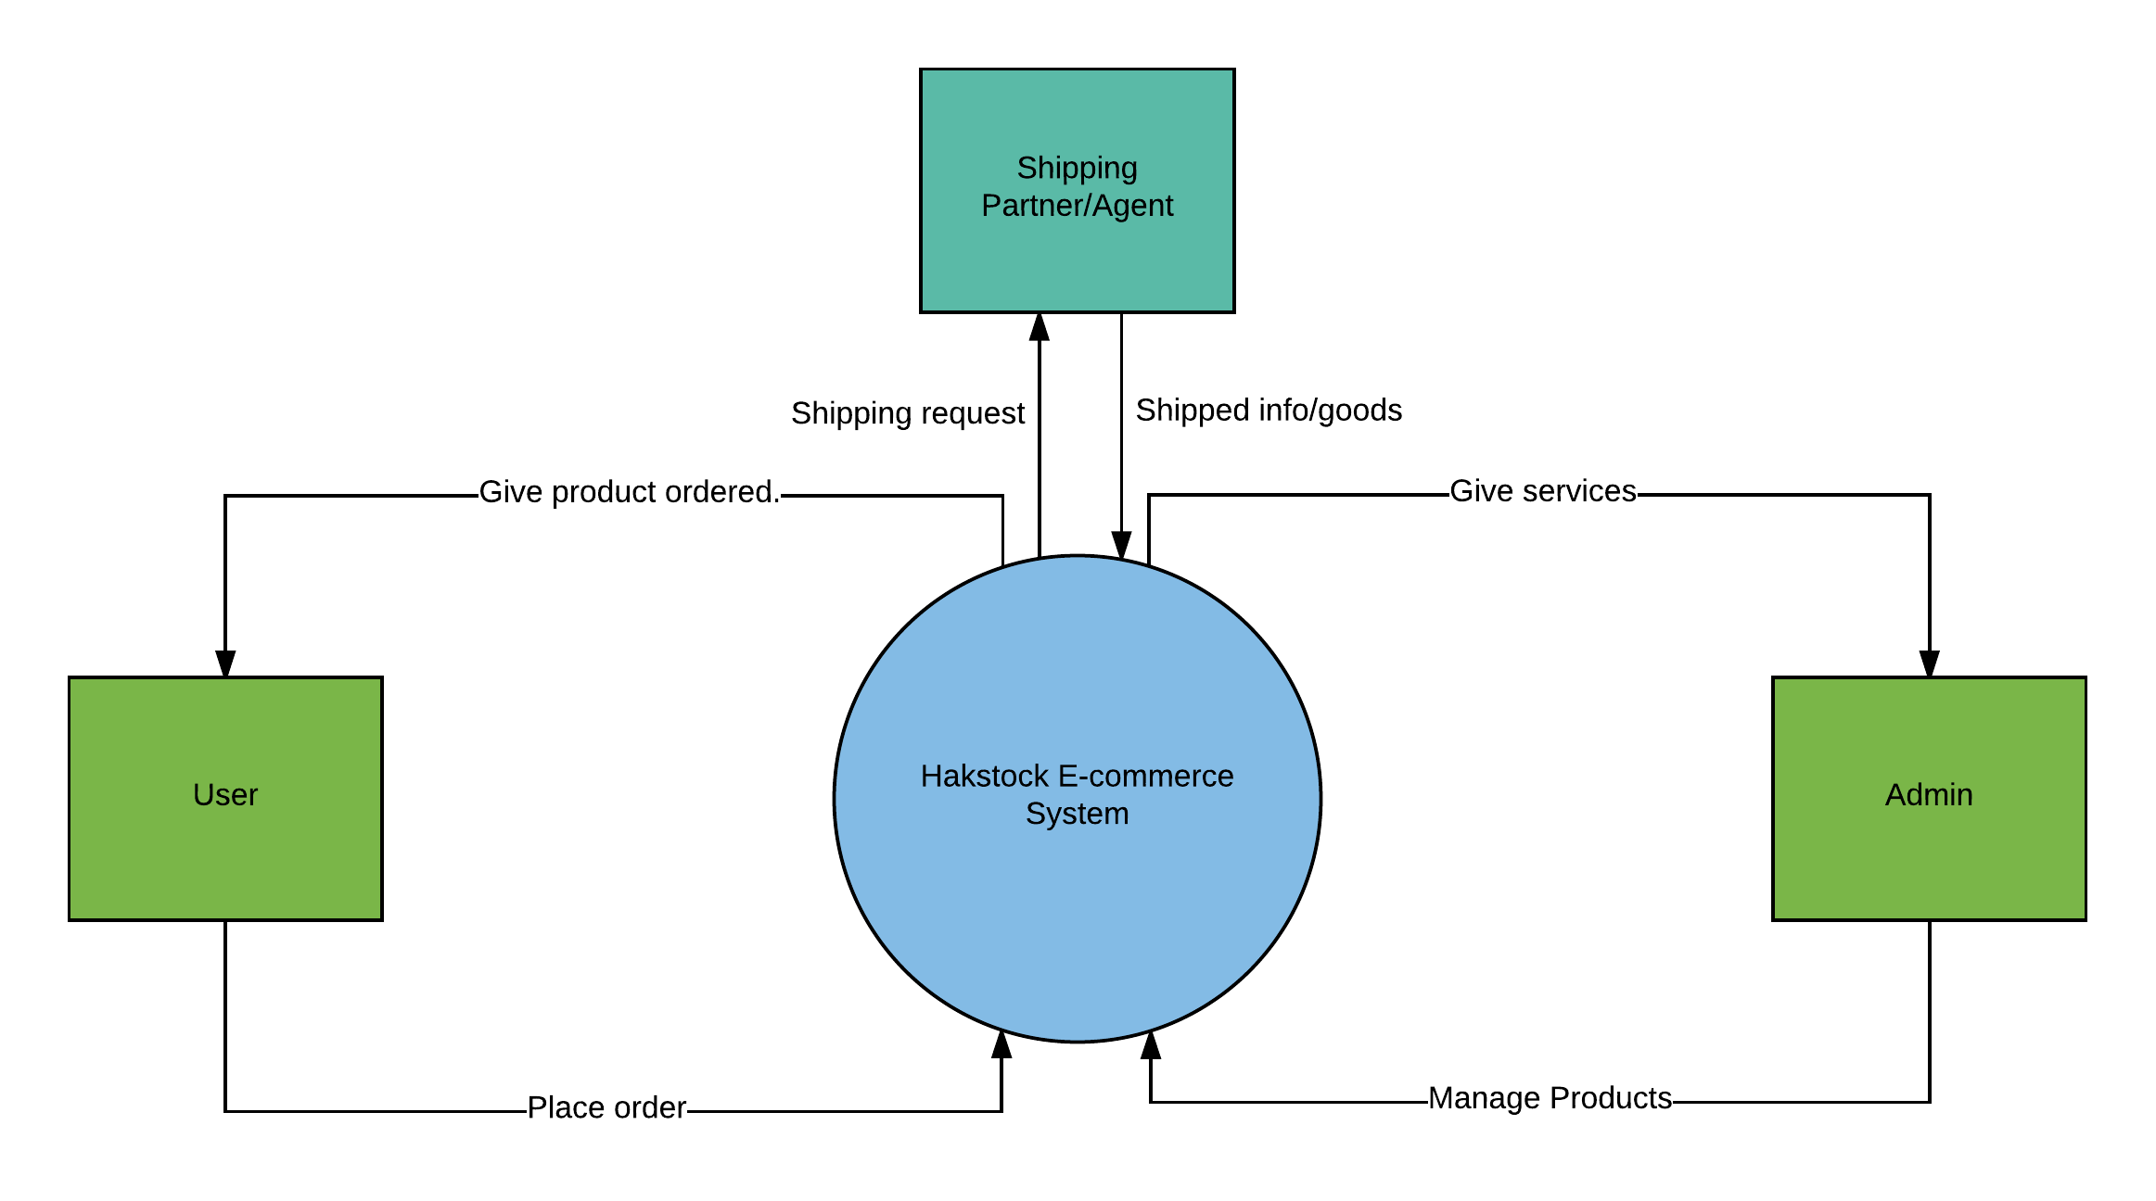

4.2.2 Level 1 User Data Flow
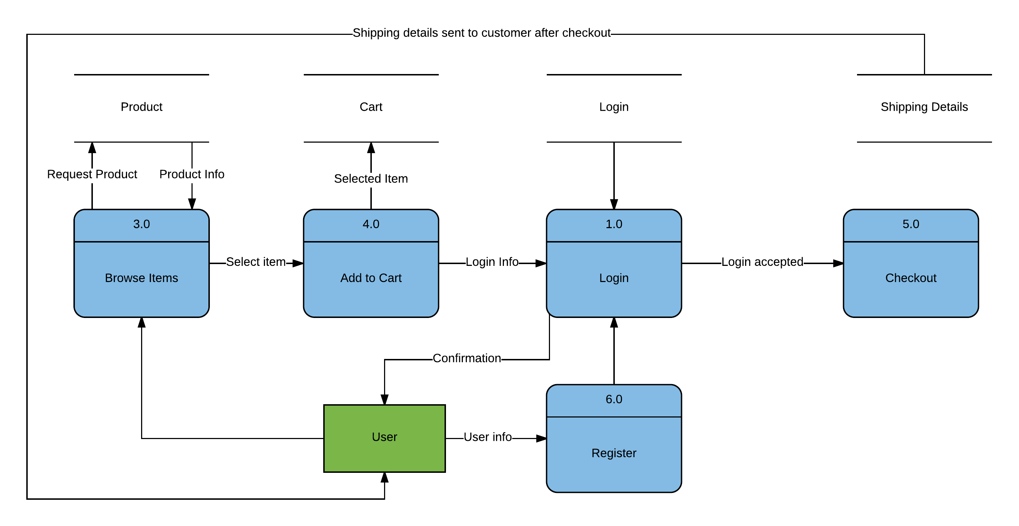

4.2.3 Level 1 Admin Data Flow
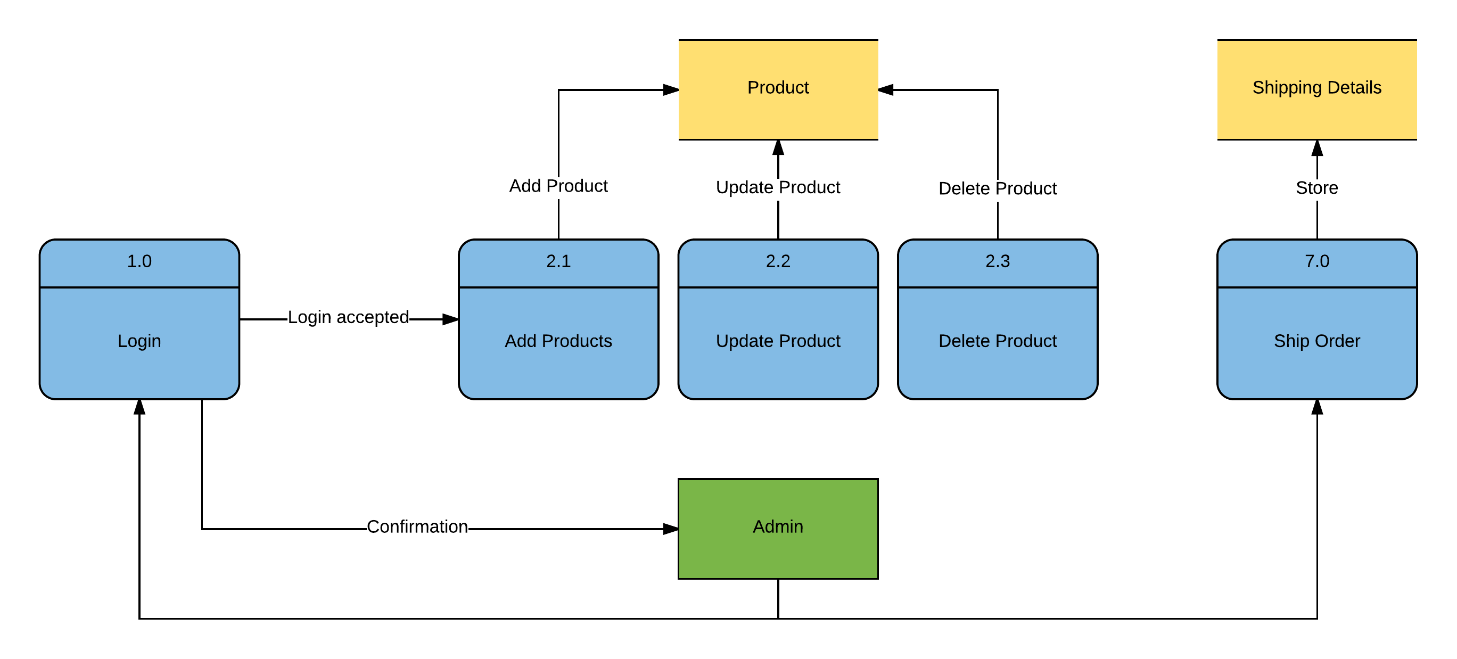

5. Change Management Process
This section of the document is intended to provide a high-level overview of the change management process to be implemented, to manage qualified changes that may occur to the Hakstock E-commerce system. A change may be an addition, modification, or removal of any crucial element. The use of the formal change management procedure will be required when any changes are discovered or requested which impact previously reviewed, approved and published project deliverables. The procedure to such changes are as follows:
- The project manager (me) identifies the necessary changes required and submit a change request to the project sponsor.
- The change request is reviewed and validated by the project sponsor. The necessary resources are provided to the project manager to complete the next phase which is the implementation of the change.
- After obtaining clearance from the project sponsor, the individual responsible for initializing the change process which is the project manager implements the mandatory changes.
- A testing plan is executed to verify the changes implemented.
- Once the changes have passed the testing phase, they are ready for deployment and to be reviewed by the project sponsor for further validation. Close the change process.

Project Manager Project Team Project Sponsor

- 